Number of crossings and GUDS were averaged for each day across all feeding stations in a habitat for a given feeding tray location (near or far).

1. How does gerbil activity vary across sparse and dense Prosopis habitats and different moon phases.

(N:near tray; F:far tray)

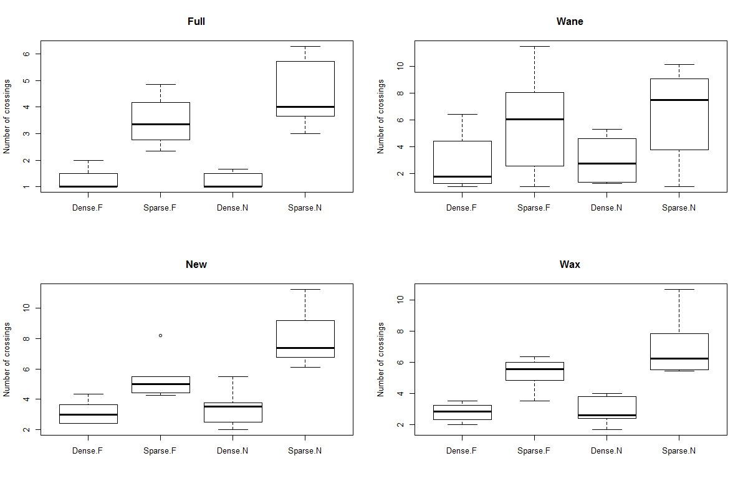

1. How do GUDs vary across sparse and dense Prosopis habitats and different moon phases?

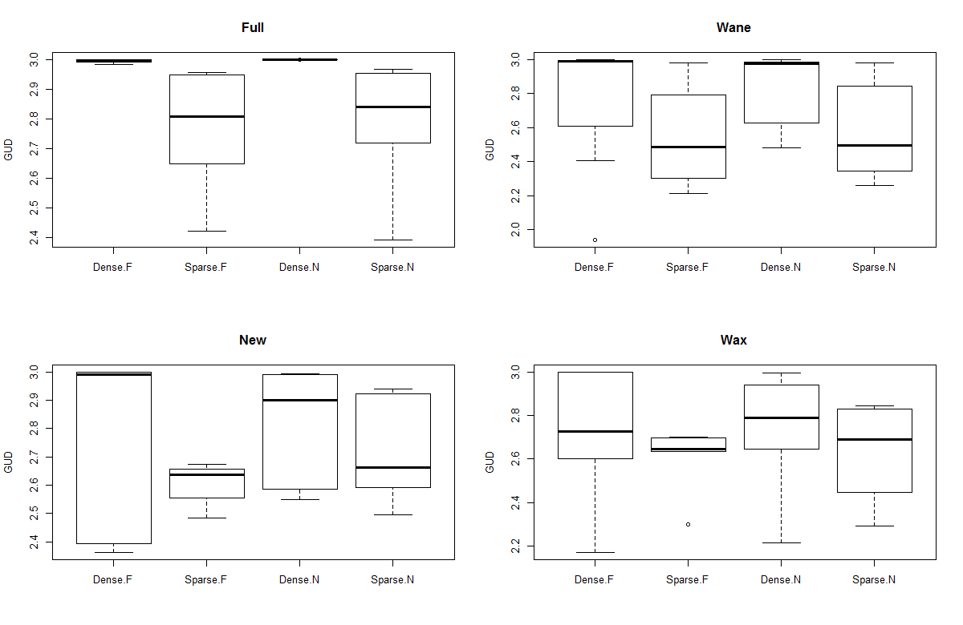

1. Tree cutting experiment: activity around feeding stations

(N:near tray; F:far tray)

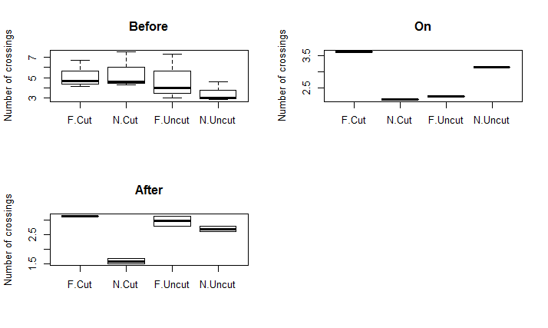

Activity around feeding stations **on** the day the trees were cut, without averaging number of crossings across feeding stations:

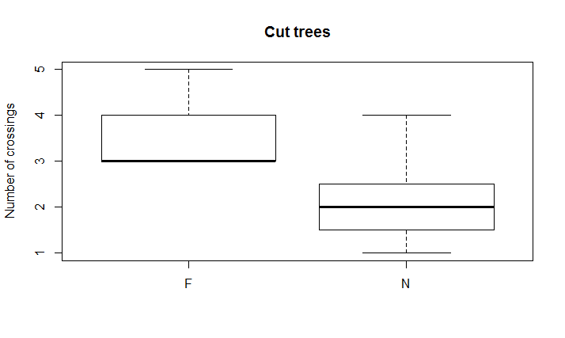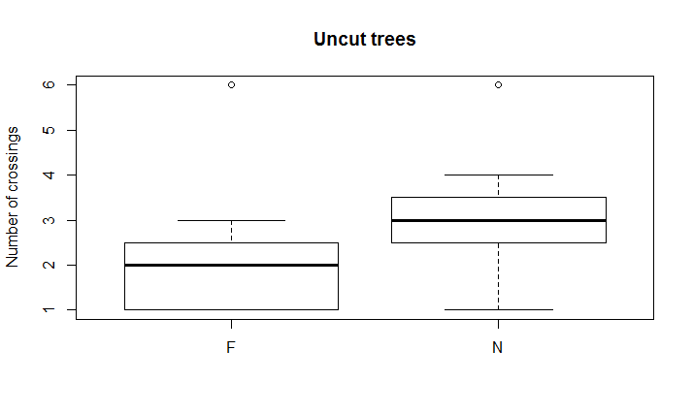

1. Tree cutting experiment: GUDS

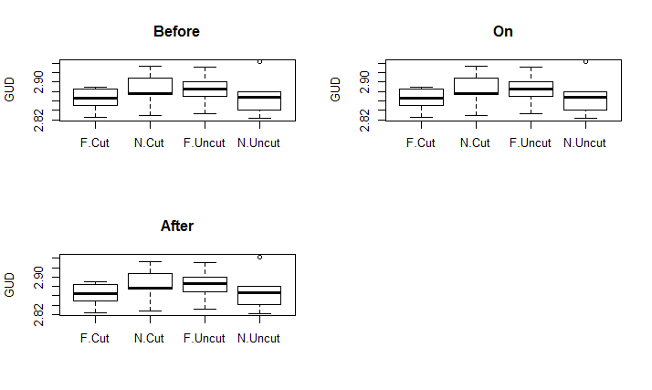

There were very few feeding stations in which gerbils had foraged; ants had consumed ~10% seeds in many feeding stations.

1. How does species richness vary with distance from colony and how does this compare to variation in species richness in the absence of a colony?

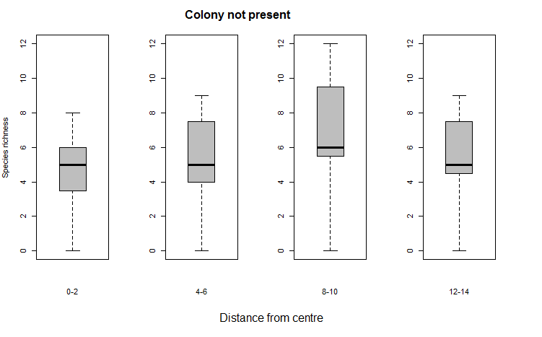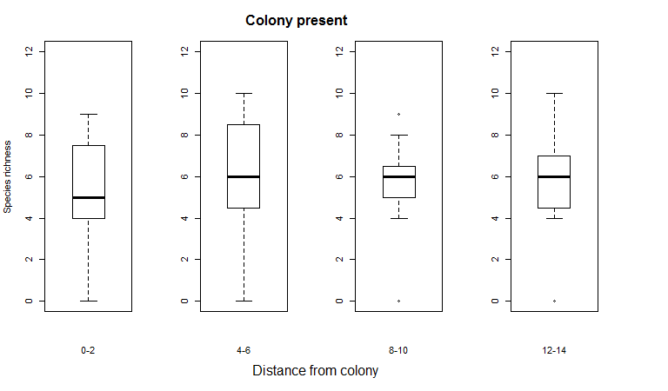

Will look at changes in species abundance next.